Case 10-Mex-Olmec-Were Jaguar Shaman-1100 BCE
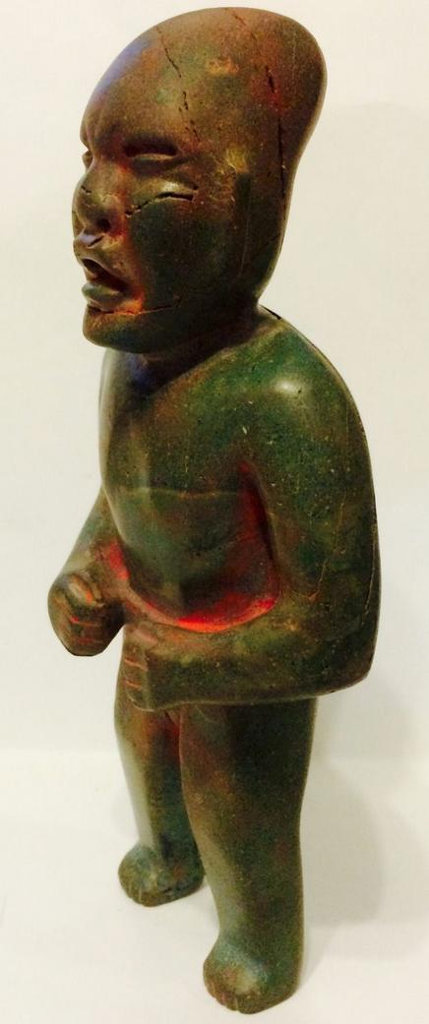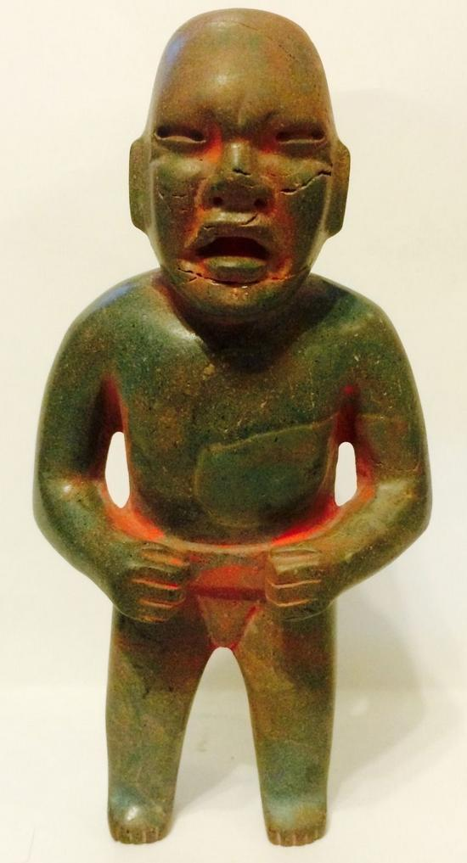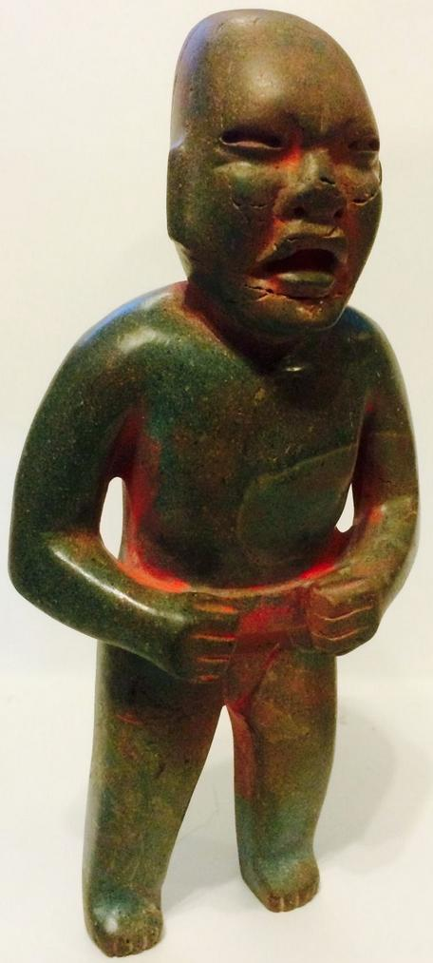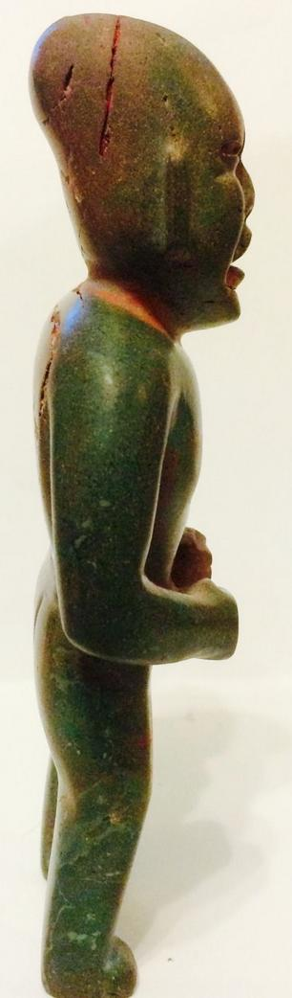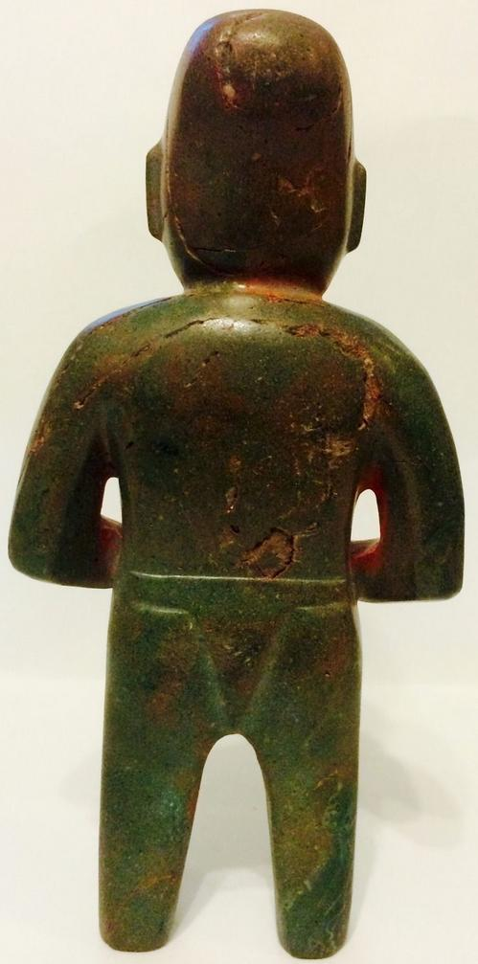

Figs. 1-5. Olmec-Were Jaguar Shaman-1100 BCE

Case no.: 14
Accession Number:
Formal Label: Olmec-Were Jaguar Shaman-1100 BCE
Display Description:
This is a were-jaguar transformation statuette or jaguar theriomorph that is designed to show the transformation of a shaman into a spiritual jaguar being, Accordingly, it emphasizes the feline wrinkles around the nose and the upcurving lips. It was found in Campeche in the early 60's when it was imported to the US. It depicts a jaguar shaman with an elongated skull on which traces of cinnabar have been applied in ceremonial activities. Erosion of the jade due to weathering is throughout the piece. It was probably placed in a shrine to which devotees were given a new identity, perhaps that of were-jaguar ancestors, because the Olmecs believed that, in the distant past, a union between a woman and a jaguar produced an earlier race of were-jaguars. The Olmecs worked mainly in stone and used jade to suggest the life-giving aspect of the were-jaguar theriomorphic conversion.
LC Classification:
Date or Time Horizon: 1100 BCE
Geographical Area: possibly La Venta area
Map:
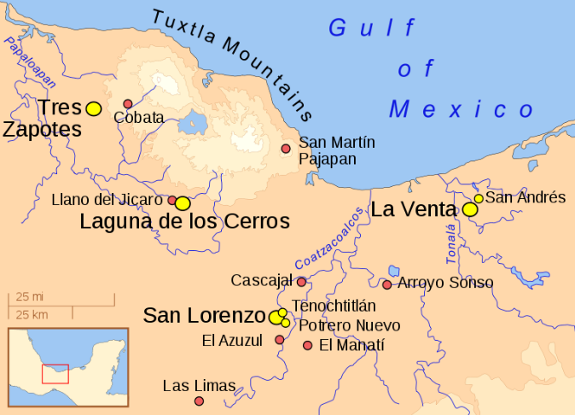

GPS coordinates:
Cultural Affiliation: Olmec
Medium: jade
Dimensions: H 6in, D 1 ½ in, W 3 in
Weight:
Condition: original
Provenance:
Discussion:
The Olmecs, the earliest known settled civilization of Central America, lived in the low-lying Gulf Coast area of what is now Mexico in about 1200-400 BCE at sites such as San Lorenzo, Tres Zapotes, Laguna de los Cerros and La Venta.
These and the other Olmec centers were well-planned and included many of the features that would be associated with later civilization in Central America including the Mexica (Aztecs) and Maya. Alongside impressive public spaces and large platform-mounds made of earth, there is evidence of a ceremonial ball game and complex astrological calendars.

References:
Bernal, Ignacio. 1976. The Olmec World. Berkeley, CA: University of California Press.
Campbell, Lyle and Terrence Kaufman. “A Linguistic Look At The Olmec.” American Antiquity. Vol. 41, January, 1976, p. 80-89.
Coe, Michael D. 1994. From The Olmecs To The Aztecs. 4th ed. London: Thames & Hudson, 1994.
— . 1996. The Olmec World: Ritual and Rulership. Princeton, NJ: The Art Museum, Princeton University.
Drucker, Philip, Robert F. Heizer, and Robert J. Squier.1959. “Excavations At La Venta, Tabasco, 1955.” Bureau Of American Ethnology. Bulletin 170.
Grove, David C. 1984. Chalcatzingo: Excavations On The Olmec Frontier. London: Thames & Hudson.
Luckert, Karl W. 1976. Olmec Religion: A Key To Middle America And Beyond. Norman, OK: University of Oklahoma Press.
Miller, Mary and Karl Taube. 1993. The Gods And Symbols Of Ancient Mexico And The Mava: An Illustrated Dictionary of Mesoamerican Religion. London: Thames & Hudson.
Sharper, Robert J. and David C. Grove, eds. 1989. Regional Perspectives On The Olmec. NY: Cambridge University .
Soustelle, Jacques. 1984. The Olmecs: The Oldest Civilization In Mexico. Garden City, NY: Doubleday & Company.

Sold by eckbalam2012 ( 85 )

Delivery package 1 of 1
Estimated delivery Wednesday, Oct 7, 2015 - Saturday, Oct 10, 2015
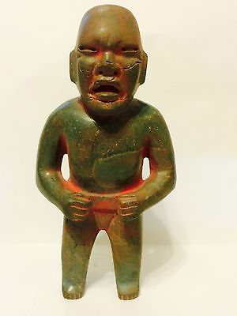

Pre columbian Transformation Olmec green stone standing figure.
Item price | $2,000.00
Quantity | 1
Item number | 271983678640
Shipping service | USPS Priority Mail

Shipping address

Ralph J Coffman Jr
149 Atlantic Ave
Swampscott MA 01907-2427
United States

Order total

Subtotal | $2,000.00
Shipping | $6.40
Total
$2,006.40

